Ministry of Foreign Affairs and Tourism
Tourism Department

HOTEL CLASSIFICATION APPLICATION FORM

General Info
- Please complete and return to the Tourism Department within the time frame stipulated.
- It is important that you provide us with the correct and complete information to ensure that your application is processed timeously.
- All applications should be signed by a duly authorized representative of the establishment.
- Please ensure that all the required documents are attached.

Hotel Information
Registered Name of the Establishment:
Trade Name:
Postal Address: |  |  | Physical Address:
Island: |  |  | Contact Number:
Email Address:
Average Occupancy Rate:
Average Room Rate:

Management Details
General Manager: |  | Contact Number:

Email Address:

- Hotel Facilities
*Please provide a list of facilities available at the hotel. (eg bars, restaurants, swimming pool etc..)

Room Categories

Total Number of Rooms:
No of Full Suites(*): |  |  | No of Half Suites (**) | :
No of Universally Accessible Rooms:

(*A full suite is considered as a suite consisting of separate bedrooms (which are closed off) and separate living area.)
(** A half/Junior suite is considered as a suite consisting of bedroom with expanded living area.)

Staffing Details
Total Number of Staff:
No of Local Employees:
No of Foreign Employees:
Current No of Students on Practical Training:

Sustainability Practices
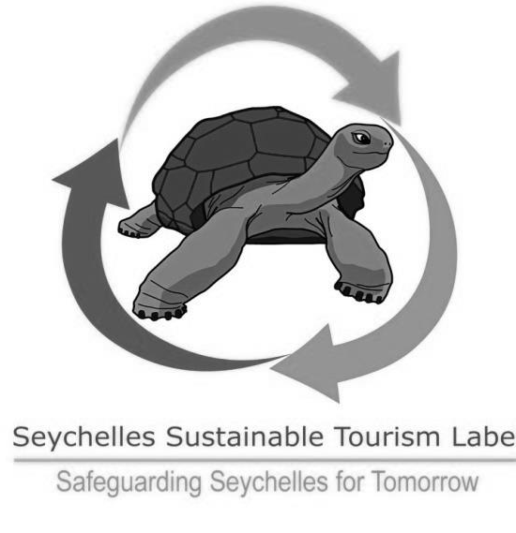

The Department would like to encourage our accommodation sector to incorporate sustainable practices in their business operations and as such a sustainability component has been included in the classification criteria.

Please indicate with a whether the hotel has a Seychelles Sustainable Tourism Label (SSTL).

*Note that establishments which are certified as a Seychelles Sustainable Tourism Label (SSTL) Hotel will qualify for 100% of the Sustainable Practices points.

YES NO

Universal Accessibility
Please indicate with a whether the hotel is willing to be assessed and graded for universal accessibility (UA).

*Note that this is a separate accolade to that of your official star grading which will specifically assess the universal accessibility facilities available at the premises. The criteria for the UA grading is attached for your information.

YES NO

Declaration

I declare that the submitted information is true, accurate and correct to the best of my knowledge.

Name:
Signature:
Designation:
Date:

Additional Information
For any additional information, kindly contact;

Mrs. Sinha Levkovic
Director Product Planning and Development
Tourism Department
Tel: 4671300
Email: sinha.levkovic@seychelles.com

