

**MINISTRY OF FOREIGN AFFAIRS AND TOURISM**

**DEPARTMENT OF TOURISM**

**EXPLANATORY NOTES FOR THE SEYCHELLES SECRETS**

**CLASSIFICATION PROGRAMME**

**NOVEMBER 2020**

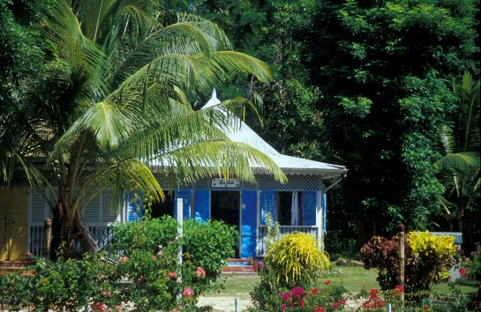

**INTRODUCTION**

As part of its hotel classification programme, the Tourism Deparment will administer a voluntary grading programme for small tourism accommodation businesses under the Seychelles Secrets brand.

The Seychelles Secrets brand will be available to licensed self-catering establishments, guesthouses and small hotels of less than 16 rooms wishing to join the programme. The programme will have three levels of awards where depending on the available facilities and services, establishments will be graded as Seychelles Secrets Gold, Seychelles Secrets Silver or Seychelles Secrets Bronze. These three levels have been developed with the aim of making the label more inclusive and able to cater to a wider selection of small accommodation businesses, while at the same time rewarding those establishments that make a greater effort to offer a product and service of a higher standard. The award will be determined by the number of points scored against the approved set of criteria.

The assessment criteria has been referenced from international standards, but its development has taken into account the local context of our tourism industry whilst also putting a special emphasis on the offer of an authentic creole hospitality, culinary and cultural experience.

Whether the property has earned a Bronze, Silver or Gold status, guests are assured that the rating has been awarded according to a set national standard and the product is above the minimum required standards.

The criteria consist of the four below components which are essential to today’s travelers:

* **Physica**l: The maintenance, condition and appearance of the establishment’s facilities. This includes cleanliness which is of paramount importance to all guests.
* **Service:** A smile, a warm and genuine welcome and willingness to please and serve customers efficiently.
* **Sustainability:** Sustainable practices which have been mainstreamed in the business operations and is essential for the continued progress of the industry.
* **Accessibility:** The establishment’s ability to cater to guests with special access needs, a sector that represents a very large market.

**OBJECTIVES OF A CLASSIFICATION PROGRAMME**

Implementation of the Classification Programme will assist the Tourism Department in achieving greater standardization and professionalism within the industry, as information regarding the quality and standards of tourism facilities and services will be provided in a more structured and transparent manner.

* Potential visitors and travel operators alike are able to make informed decisions and choices and get the assurance that they/their clients will receive value for money.
* Sharpen the destination’s image, as the programme acts as a primary marketing tool for the industry creating better awareness of the product offering.
* Works as a development tool to raise standards by providing operators with information on shortcomings and necessary improvements needed to maintain a grade or improve on it.
* Provide a control instrument to measure quality and sustainability.
* Acts as a benchmarking instrument which enhances fair competition.

**STATUTORY OBLIGATIONS**

To be considered for the grading programme, the establishment should be in compliance with all relevant statutory requirements including that of the Public Health Section, Fire & Rescue Services Agency, Seychelles Licensing Authority and Planning Authority.

**IMPLEMENTATION PLAN**

Establishments will be offered an advisory visit which will provide techical assistance on the content of the criteria and explain the processes to become graded. During the visit, should it be in agreement with the operator, a pre-assessment can be carried out to provide an insight into possible rating.

If the operator wishes to pursue grading under the programme, an offical visit will need to take place. Prior to the official visit, an application form will need to be filled in and submitted, together with required supporting documents.

The official assessment visit will be carried out by an officer of the Tourism Department, on a date suitable to both parties, to determine the establishment’s standards as per the criteria.

For the recertification of an establishment after the 2 year validity period, an assessment will be carried out approximately four months prior to the expiry date of its certification.

**APPLICATION FEES**

The initial assessment visit will be conducted free of charge. All further assessment visits may be conducted at a fee stipulated under the Department’s established regulations.

**MONITORING**

With the aim of ensuring that graded establishments are maintaining their standards, the Tourism Department may conduct surprise visits within the certification period for monitoring purposes. Establishments whose standards have dropped will be advised accordingly and a grace period will be given to address shortcomings. Where it is felt that an establishment is persistently not maintaining its standards in spite of recommendations from the Department, actions including suspension or revocation of the award may be taken as per established regulations.

**VALIDITY OF AWARD**

The award shall be valid for a period of 2 years from the date of issue, unless revoked by the Department.

**AWARD**

A certificate will be awarded to establishments displaying its achieved standard ie: Seychelles Secrets Bronze, Seychelles Secrets Silver or Seychelles Secrets Gold, to be displayed in a conspicuous place at the establishment. This will be at the cost of the Tourism Department. The award will also feature on the Seychelles Tourism Board website and other promotional materials.

Below features the logo designed for the three levels of award, which will be dispayed on the certificates.



**PENALTIES**

Accommodation businesses which chooses not to be graded under the programme shall not be permitted to use the Seychelles Secrets logo in their marketing and advertisements. Doing so shall be constituted as an offence and the person shall be liable on conviction to a fine not exceeding SCR100,000.

If establishments are displaying ratings obtained from guest reviews on their online booking platforms, then it should be specified that the ratings are given by their guests and are not related to the national classification system.

**THE ASSESSMENT FORMS**

**Assessment Categories**

The diaspora of small establishments in Seychelles is very diverse where a wide range of products, facilities and services are on offer. One notable difference can also be seen in the type of operations required for the difference licence categories. For example, a self-catering business is not required to provide meals as compared to a guesthouse or small hotel which will automatically have to provide these services.

For this reason, the Tourism Department has deemed it more appropriate to develop three separate criteria in order to cater for establishments with different product offerings, to facilitate the interpretation of the criteria and also to simplify the assessment process and its scoring system. Establishments will be assessed using a specific assessment form for their appropriate category as per the below:

1. Small Hotels/ Fully-fledged Guesthouses (ie Guesthouses offering HB/FB)
2. Self-Catering
3. Bed & Breakfast Guesthouse

For self-catering establishments, whilst they will all be assessed on the criteria for self-catering, there will however be two separate score sheets, one for establishments of up to 4 units and one for those above 4 units. This has been done to compensate for the difference in the facilities required to be provided by the two groups, where self-catering businesses of above 4 units need to provide reception and public toilets and those with less than four units are not required to provide these facilities.

**Assessment Areas/Themes**

The assessment forms are divided into main themes which are common in a tourism accommodation grading schemes and are specific to the category, services and facilities on offer, as per the below table.

|  |  |  |
| --- | --- | --- |
| Small Hotel/Fully-Fledged Guesthouse | Self-Catering | Bed & Breakfast Guesthouse |
| 1. Location, Access & Exterior | 1. Location, Access & Exterior | 1. Location, Access & Exterior |
| 2. Safety & Security | 2. Safety & Security | 2. Safety & Security |
| 3. Reception | 3. Reception | 3. Reception |
| 4. Guest Bedrooms | 4. Guest Units | 4. Guest Bedrooms |
| 5. Guest Bathrooms | 5. Guest Bathrooms | 5. Guest Bathrooms |
| 6. Food & Beverage | 6. Kitchenette | 6. Food & Beverage |
| 7. Kitchen | 7. General | 7. Kitchen |
| 8. General |  | 8. General |

**TABLE 1**

**Assessment Content**

The themes of the assessment criteria is further developed into a number of elements which describes either the existence or availability, quality and condition of the facility as well as the service on offer. These are outlined below;

***RECEPTION SERVICE***

Booking process, cancellation policy, online bookings, registration, telephone, welcoming, willingness to please and serve customers, reception setting, after hours contact

***GUEST BEDROOMS/UNITS***

Cleanliness, comfort, interior decoration, bedding & linens, in-room amenities, furniture & fittings

***LOCATION, ACCESS & EXTERIOR***

Natural beauty, the view, neighbourhood, access to the establishment, proximity to amenities, building exteriors, first impressions, parking, grounds & gardens

***SAFETY & SECURITY***

Safety & security measures in place at the establishment.

***GENERAL***

Cleanliness, staff appearance & friendliness, readiness to serve and help guests, internet facilities, laundry service, sustainable practices, universal accessibility & maintenance

***BATHROOMS***

Cleanliness, comfort, condition & quality of fixtures & fittings, supply & quality of towels, bathroom amenities

***FOOD & BEVERAGE***

Cleanliness, local cuisine, entertainment, crockery/cutlery, service hours, décor & furnishings

***KITCHEN/***

***KITCHENETTE***

Cleanliness & hygiene, fittings & equipment, appliances, crockery, cutlery, glassware

**Mandatory Criteria**

The forms also consist of mandatory requirements which are marked “M”. These carry no points and refers to basic requirements deemed necessary for an establishment to operate effectively. In the event that an establishment fails to meet one of the mandatory requirements, it will not be graded until such time that the Department is informed by the establishment that the mandatory requirement is complied with and a revisit is conducted to ascertain same.

**THE SCORING SYSTEM**

For each criterion, an establishment can score between 0 and 3 points depending on their level of product offering and services available. The final scoring will be determined by a percentage bracket of the accumulation of points which the establishments has gained against the total possible score. The total possible score for the different categories, number of mandatory requirements and percentages required for each level are shown in the tables below;

|  |  |  |  |  |
| --- | --- | --- | --- | --- |
| CATEGORIES OF ESTABLISHMENTS | Small Hotel/ Fully fledged Guesthouse | Bed & Breakfast Guesthouse | Self-Catering 4+ | Self-Catering |
| MANDATORY | **27** | **26** | **25** | **23** |
| TOTAL POSSIBLE SCORE | **150** | **141** | **135** | **120** |

**Table 2**

|  |  |  |
| --- | --- | --- |
| *AWARD RATING* | *% SCORE BRACKET* | *SEYCHELLES SECRETS GRADING INDICATOR* |
| Not Graded | 0%-34% | Not meeting minimum standards to be graded |
| BRONZE | 35%-49% | Comfortable and well-presented |
| SLIVER | 50%-65% | Good level of quality and comfort |
| GOLD | 66%-100% | Excellent standards throughout |

**Table 3**

The below is an extract of the assessment criteria and its various components.

**Mandatory Criteria (M); all establishments must comply with these; carries no points**

**Achieved Score**

**Description of the criteria components.**

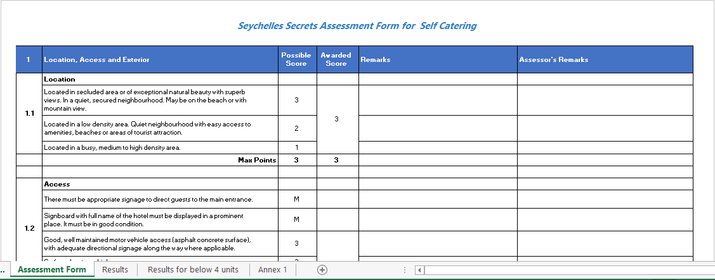

✓

✓

**Main Theme**

**FLOW CHART FOR THE ASSESSMENT PROCESS**

**Establishment officially applies for the programme by filling in the application form and submits required documents.**

**Submitted documents are verified and suitable date is set for assessment visit.**

**Assessment carried out in presence of manager or designated responsible person**

**The Department makes a decision on the proposed grading**

**Assessment report is compiled and verified**

**Debrief with manager about issues noted during the assessment**



**GRADING IS PUBLISHED**

**(Valid for 2 yrs)**

**Re-Assessment**

**(4 months prior to expiry of rating)**

**Grading communicated to establishments**

**Monitoring Visits**

**Establishments not meeting Mandatory Requirements are asked to inform the Department once recommendations are implemented for revisit to be effected.**

**Establishments aggrieved with the grade granted may within 14 days make an appeal to the Appeals Board.**

**Maintains decision of the Department**

**Appeals Board**

**Review decision of the Department if appeal is justified**