NOVEMBER 2020

Explanatory Notes

**SEYCHELLES HOTEL CLASSIFICATION PROGRAMME**

**MINISTRY OF FOREIGN AFFAIRS AND TOURISM**

**Department of Tourism**

**INTRODUCTION**

The aim of the hotel classification programme is to achieve a greater degree of standardization and professionalism within the tourism industry. An established grading system allows discerning visitors to know any hotel’s standard in advance and what to expect of the product offering before making a purchase. It is important to understand that one of the major factors that influence a visitor’s choice of a destination is the standard of facilities and services on offer.

Governments as well as private sectors in the neighbouring comparable destinations are devoting increased attention and resources on raising the overall standard of accommodation facilities and sharpening the skills of resorts employees. If the Seychelles is to compete effectively with these destinations, it is imperative that due attention is given to this important aspect of the hospitality operation and management.

The setting up of this Classification System is necessary to better showcase our product diversity, allow establishments to better sell their products and manage clients’ expectations.

For this programme, a set of criteria has been developed consisting of physical, service, sustainability and guest ratings assessment areas.

The Department also wants our industry to embrace access for all, and as such, we have devised a separate set of criteria which will assess Universal Accessibility facilities available at our hotel properties. The award will be voluntary and hotels which have achieved the required number of points to qualify for this accolade will be given a separate award & plaque. This is a new initiative which has seen the universal accessibility facilities which were previously incorporated in the hotel classification criteria removed and developed into a separate criteria. Further explanation on how the award for Universal Accessibility will work can be accessed in **Annex 2**.

**OBJECTIVES OF THE CLASSIFICATION PROGRAMME**

Implementation of the Classification Programme will assist the Tourism Department in achieving greater standardisation and professionalism within the industry, as information regarding the quality and standards of tourism facilities and services will be provided in a more structured and transparent manner.

* Potential visitors and travel operators alike are able to make informed decisions and choices and get the assurance that they/their clients will receive value for money.
* Sharpen the destination’s image, as the programme acts as a primary marketing tool for the industry creating better awareness of the product offering.
* Works as a development tool to raise standards by providing operators with information on shortcomings and necessary improvements needed to maintain a grade or improve on it.
* Provide a control instrument to measure quality and sustainability.
* Acts as a benchmarking instrument which enhances fair competition.

**QUALIFICATION FOR HOTEL GRADING SYSTEM**

Star grading will be mandatory for all hotel establishments with more than 50 rooms and eligible on a voluntary basis to hotels having 50 rooms and below.

**STATUTORY OBLIGATIONS**

The hotel should be in compliance with all relevant statutory requirements including that of the Public Health Section, Fire & Rescue Services Agency, Seychelles Licensing Authority and Planning Authority.

**VALIDITY OF GRADING**

The grading shall be valid for a period of 2 years from the date of issue, unless revoked by the Department.

**ASSESSMENT FEES**

As per the new regulations which are to be established, the Department will conduct the initial assessment visit free of charge. All further assessment visits will be conducted at a fee stipulated under the Department’s Regulations.

**AWARD**

A plaque stating the hotel’s achieved star rating will be awarded to all establishments and this will need to be displayed at a conspicuous place. The plaque will be accompanied by an official letter and certificate stating the establishment’s final grading.

The grading will feature on the Department’s & Seychelles Tourism Board website and other promotional materials.

**PENALTIES**

A licensed accommodation who fails to display or market itself as per the grading awarded will be given a first warning in writing with a rectification period of 14 days. Failure to adhere to the notice will constitute an offence under the Department’s regulations and penalties will apply.

Accommodation businesses which chooses not to be graded under the programme shall not be permitted to use the star grading insignia in their marketing and advertisements. Doing so shall be constituted as an offence and the person shall be liable on conviction to a fine not exceeding SCR100,000.

If establishments are displaying ratings obtained from guest reviews on their online booking platforms, then it should be specified that the ratings are given by their guests and are not related to the national classification system.

**THE ASSESSMENT CRITERIA EXPLAINED**

***Assessment Criteria Elements***

The Star Rating criteria has been referenced from international standard, but its development has been applied to the local context of our tourism industry. Whether the property has earned a 1 Star or a 5 Star Rating, guests are assured that the rating has been awarded according to a national set of standards.

The criteria consist of the four below elements which are essential to today’s travellers:

* **Physical**: the maintainance, condition and appearance of the hotel’s facilities. This includes cleanliness which is of paramount importance to all guests.
* **Service**: A smile, a warm and genuine welcome and a willingness to please and serve customers efficiently.
* **Sustainability**: Mainstreaming of sustainable practices in hotel operations.
* **Guest Ratings:** Online presence and reputation of the establishment. Hotel properties will be awarded points according to their ReviewPro GRITM score achieved over the last 365 days.

***‘Guest Ratings’ Assessment***

A newly introduced assessment area has been incorporated into the hotel classification criteria which will give weight to the experiences and feedbacks of the guests who have stayed at our hotels. The reviews and ratings being generated by guest platforms can be used in the advantage of destination authorities to gain an insight into the perceived level of service of our properties.

In view of the growing importance of guest reviews and on its ability to impact on guests purchase decision, the Department has taken the decision to engage the services of ReviewPro, an online reputation company which uses a guest intelligence software to gather and analyse guest review data and generate an online reputation score for each of our property.

Hotels will be awarded points based on their ReviewPro score over the last 365 days. Please refer to the below ***Annex 1*** on ‘Integration Of Reviewpro In The Hotel Classification Programme.’

***Categories of the Assessment Criteria***

Tourism establishments eligible for grading will be assessed on specific assessment forms designed to cater to their product offerings as per the below categories:

* Hotels (on Mahe, Praslin & La Digue) of 25 rooms and above
* Hotels (on Mahe, Praslin & La Digue) below 25 rooms
* Island Resorts on all other islands of 25 rooms and above
* Island Resorts below 25 rooms

This has been done to ensure that the variance in the sizes, location, range of facilties and operational needs is taken into account so that no establishment is put at a disadvantage of losing out on points.

***Components of the Assessment Form***

* **Category Entry Requirements**

These refer to basic requirements deemed absolutely necessary for an establishment to operate effectively and need to be met in order for the establishment to be considered for grading.

* **Mandatory Criteria marked “M”**

The Mandatory requirements refer to those requirements that are prescribed in the Minimum Criteria for Hotels which the establishment must meet in order to be licensed. It features across most areas of the assessment form and carries no points. Should a hotel fail to meet the Mandatory Requirements, no star rating will be issued to the establishment until such time that it complies with it.

* **Assessment Areas**

The star rating criteria is divided into eleven (11) areas that are common in a hotel grading scheme. Each area consists of a number of indicators which describe either the existence or availability, quality and condition of the facility as well as the service offered.

* **Indicative Scores**

This shows the value of points assigned to each elements.

* **Required Criteria**

The criteria consists of a number of criteria which have been marked ‘R’ and which are required for each star grading band. These have been based on customer expectations and a hotel will need to meet 85% of the required criteria of its grading band to achieve that particular rating. In the case where a hotel does not meet the 85%, the hotel will be downgraded to the next lower star level.

These criteria link together; only one out of the possible points can be scored. Points can also be scored in between as applicable

Demarcates Required criteria (R) for each star category

Description of the star rating Criteria

Criteria indicator: Service, Physical, Sustainability

Mandatory criteria (M); all hotels must comply with these; carries no points

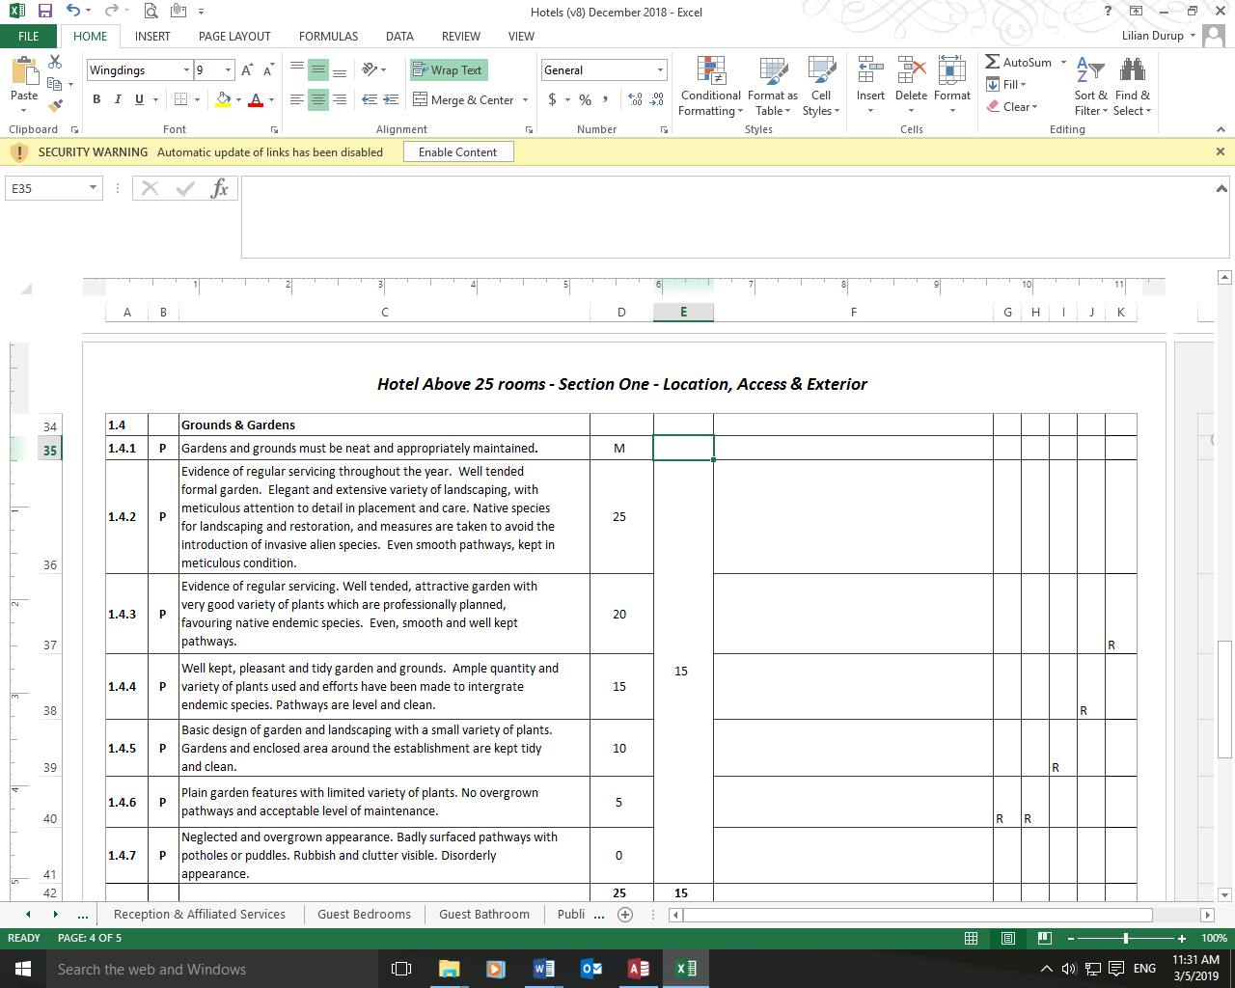

Achieved

Score

**HOW IS THE STAR RATING DETERMINED**

To obtain higher stars, progressively higher service and quality, state of maintenance on quality of furnishings and improved business practices such as environmental management should be provided across all areas.

Based on the findings, observations and state of operation on the day of the visit, each element of the assessment criteria will be given a deserving score.

A weighting system will then be used to calculate the final score achieved by the hotel. Each assessment area has been assigned a percentage weighting and this will be tallied to provide a final % score. The percentage weighting that these areas contribute to the total score is shown in the table below:

|  |  |
| --- | --- |
| Section | Weighting % |
| Location, Access & Exterior | 3% |
| Reception & Affiliated Services | 9% |
| Guest Bedroom | 18% |
| Guest Bathroom | 10% |
| Public Areas | 6% |
| Restaurant & Bars | 10% |
| Kitchen | 3% |
| General Services | 7% |
| Business Practices | 12% |
| Activities, Entertainment, Facilities | 10% |
| Guest Ratings | 12% |
| TOTAL | **100%** |

**TABLE 1**

The below grading bands will be used to determine the hotel’s final grading. Hotels scoring less than 30% will be termed ’Not Graded’.

|  |  |  |
| --- | --- | --- |
| *STAR RATING* | *Total Score* | *Star Grading Indicator* |
| Not Graded | 0% to 24% | *Not meeting minimum requirement* |
| 1 star | 25% to 39% | *Simple, comfortable, no frills* |
| 2 star | 40% to 54% | *Comfortable and well-presented* |
| 3 star | 55% to 69% | *Good level of quality and comfort* |
| 4 star | 70% to 84% | *Excellent standards throughout* |
| 5 star | 85% to 100% | *Exceptional with a degree of luxury* |

**TABLE 2**

**IMPLEMENTATION PLAN**

***For Mandatory Establishments***

Assessments will be carried out by officers from the Tourism Department to determine the establishment’s standards as per our criteria. Establishments will be notified of upcoming visits in advance.

The assessment report will be compiled and verified by the Department.

Following the verification process, a tourism establishment shall be informed of its proposed grading and shall be given a period of 7 days to review and respond to the proposed grading with their comments. The secretariat may wish to review, request another visit or maintain the original decision of the Department. The Department will maintain its proposed grading should an establishment fail to respond within the 7 days.

For establishment which have failed to meet a Mandatory Criteria, the establishment will be given a grace period to address these issues afterwhich a reassessment will be conducted to ascertain compliance for the achieved grading to be awarded.

After this process has been completed, the Ministry shall pronounce the official grading of all tourism establishment.

Establishments scoring between and 0-29% and thus not meeting at least the ‘One Star’ grade will be termed “Not Graded”. The Department will give them a grace period or they will remain as not graded until the next certification period.

An establishments aggrieved by any decision of the Department will have recourse for Appeal, through the Appeals Board. The establishment may within fourteen days of the notification of the decision lodge an appeal, where the Appeals Board will have twenty one days from the date of receipt of the appeal to review and give a decision to affirm or amend the decision of the Department.

***Establishments wishing to Participate on Voluntary Basis***

Establishments will be offered an advisory visit which will provide techical assistance on the content of the criteria and explain the processes to become graded. During the visit, should it be in agreement with the operator, a pre-assessment can be carried out to provide an insight into possible rating.

If the operator wishes to pursue grading under the programme, an offical visit will need to take place. Prior to the official visit, an application form will need to be filled in and submitted, together with required supporting documents.

The official assessment visit will be carried out by an officer of the Tourism Department, on a date suitable to both parties, to determine the establishment’s standards as per the criteria.

For the recertification of an establishment after the 2 year validity period, an assessment will be carried out approximately four months prior to the expiry date of its certification.

***Monitoring Visits***

The Department may at its discretion conduct monitoring visit during the two year period.

Establishments whose standards have dropped will be advised accordingly and a grace period will be given to address shortcomings. Establishment that no longer meet the criteria requirements of the grading system may have their award suspended or revoked by the Department.

***Re- Assessments***

Re-assessment visits will be carried out approximately four months prior to the expiry date of the hotel’s star rating.

A hotel can only have its star rating upgraded at the time of the next assessment.

**THE ASSESSMENT VISIT**

Establishments will be given due notice of scheduled assessment visits. The notice will come with an application form requesting some important details as well as the submission of certain documents relevant to the assessment visit. At this point, hotel will be asked to indicate whether they would like to be assessed for the Universal Accessibility award. The establishment will have a period of 7 days to return the application form to the Department with confirmation of the proposed date together with requested documents.

On the day of the visit, an initial briefing will be conducted with the General Manager to go over the days’ programme. This will also be the opportunity for the Management to clarify any concerns. All available facilities of the resort (including front and back of house) will be assessed and it would be ideal to have the presence of all Departmental Heads on site for the visit. Photographic evidence will need to be taken and queries may also be directed at team members.

To ensure smooth running of the days programme, the Management needs to prepare;

* An entry level room to be assessed.
* At least one in each of the other room categories available at the hotel to be visited.
* A table set for dinner service.

The service delivery of the F&B area is part of the assessment criteria and assessors will need to experience and score the lunch service of the hotel. The Department would appreciate the hotel’s assistance in serving lunch to the assessors where they will need to order from the lunch menu. As the assessor’s will be debriefing on the assessment progress and plan for the remainder of the days’ programme, the lunch will need to be unaccompanied by any hotel representative.

At the end of the assessment visit, a debriefing will be done with the hotel’s representative to outline the observations made. Establishments will however not be provided with a potential grading at this time.

**SUMMARY**

In summary, the establishment must fulfill the following to be graded 1 to 5 Star;

* Meet all Category Entry Requirements
* Meet all Mandatory Requirements (M)
* Achieve 30 to 100 % of the Total Weighted Score
* Meet 85% of all Required Criteria (R) of its star category

**START**

**Operator informed of assessment visit**

**Final grading is approved by the Department.**

**Assessment report is compiled and verified.**

**Operator confirms proposed date and submits required documents within 7 days**

**Debrief with manager about issues noted during the assessment**.

**Assessment visit carried out in presence of manager or designated responsible person**

**Achieved grading communicated to all establishments where they will be given a period of 7 days to respond to the proposed grading with their comments.**

**Re-Assessment**

**(4 months prior to expiry of star rating)**

**GRADING IS OFFICIALLY PUBLISHED**

**(Valid for 2 yrs)**

**Satisfactory Compliance**

**Establishments not meeting Mandatory Requirements will be advised accordingly and given grace period to effect necessary actions for revisit to be conducted.**

**Establishment will be termed Not Graded.**

**Non Compliance**

**Monitoring Visits**



**Establishments are in aggrement with the final proposed grading**

**Ministry will review feedback and comments & make a decision on whether to maintain the proposed grading or amend same.**

**Establishments aggrieved by the final grading will have recourse for appeal through the Appeals Board, within 14 days of being informed of the final grading.**

**Appeals Board will review submitted appeals and make a decision to affirm of amend the decision of the Department.**

FLOWCHART FOR GRADING PROCESS

**ANNEX 1**

**INTEGRATION OF REVIEWPRO IN THE HOTEL CLASSIFICATION PROGRAMME**

**Introduction**

Online guest reviews has tremendously transformed and impacted on the tourism accommodation sector over the recent years. It has not only become a main influence on the decision making process of potential visitors but has also impacted on the image and reputation of hotel properties.

Obtaining data from online guest reviews can be very beneficial to hotel properties, destinations as well as grading bodies as it is a constant source of feedback on performance and service levels. Globally, there are a number of companies which have been formed to provide the service of capturing and analyzing this online feedback data.

The Tourism Department has taken the decision to incorporate online guest reviews into its hotel classification system to take into account the experiences of guests who have stayed at our hotels and also to strengthen the criteria. This will be done through a 3-year contract with ReviewPro, signed in April 2018. The contract will give the Department access to real time analysis and data on guest reviews for 56 hotel properties which are to be star graded over a period of 3 years.

**Why are guest reviews important to the accommodation sector?**

Guest opinions and experiences are of significant importance to the accommodation sector and has the ability to greatly impact on purchase decisions. According to the UNWTO report, the average number of travel sites visited by a sample of just under 400 consumers during the 60 days prior to making a booking is 13.60. It was also found that consumers on average performed 8.60 travel-related searches on search engines such as google, Yahoo or Bing.

This translates that potential visitors rely greatly on review sites to be provided with guidance on the quality, services and facilities to be expected at a hotel property. The reviews and ratings being generated by guest platforms can therefore be used in the advantage of destination authorities to gain an insight into the perceived level of service of these properties.

**What is ReviewPro?**

ReviewPro is a guest intelligence software that gathers data from more than 175 of the most important travel review sites worldwide in more than 45 languages. The data is retrieved from the internet 10 times a day and can deliver key metrics on hotel properties with in-depth analysis on rankings, ratings, competitive positioning, semantic analysis, departments and overall reputation of these properties.

**How ReviewPro works**

All review sites require the consumer to give a general evaluation of their experience as well as a rating which is normally based on a scale of 1-5 or 1-10. The ReviewPro software conducts an in-depth analysis of these guest ratings and calculates a Global Review Index (GRITM) score for each property.

The GRITM online reputation score can be used to benchmark hotels, groups of hotels or chains, make comparisons between properties, compare results with their competitors and track the evolution of a hotel’s performance over time. This score can be calculated daily, monthly or over a one year period.

However, in order to generate a GRITM score, the software requires that a minimum of 25 reviews have been posted on the hotel property within the past 365 days.

**Integration of ReviewPro into the Seychelles Hotel Classification Programme**

To integrate the guest feedback scores into the hotel classification standards, the Department has inserted a new section which will be headed “Guest Ratings”, making a total of 11 sections altogether.

Hotel properties will be awarded points according to their GRITM score achieved over the last 365 days as per the excerpt of the assessment criteria seen below. (Please see attached excel sheet showing the GRI scores achieved by our hotels over last 365 days, with total points achieved)

|  |  |  |  |  |
| --- | --- | --- | --- | --- |
| **11.00** |  | **Guest Rating** | **Indicative Score** | **Actual Score** |
| **11.1** | **S** | The hotels has achieved a ReviewPro GRI score of between 90 – 100% for the period of last year. | 5 |  |
| **11.2** | **S** | The hotels has achieved a ReviewPro GRI score of between 80 – 89% for the period of last year. | 4 |
| **11.3** | **S** | The hotels has achieved a ReviewPro GRI score of between 70 – 79% for the period of last year. | 3 |
| **11.4** | **S** | The hotels has achieved a ReviewPro GRI score of between 60 – 69 % for the period of last year. | 2 |
| **11.5** | **S** | The hotels has achieved a ReviewPro GRI score of between 50 – 59 % for the period of last year. | 1 |
|  |  | **Max Points** | **5** | **5** |

The weighting of the hotel classification standards have also been amended to include this new section, which will carry a total weighting of 12%.

|  |  |  |
| --- | --- | --- |
|  | **Area** | **% weight** |
| 1 | LOCATION, ACCESS & EXTERIOR | 3% |
| 2 | RECEPTION & AFFILIATED SERVICES | 9% |
| 3 | GUEST BEDROOM | 18% |
| 4 | GUEST BATHROOM | 10% |
| 5 | PUBLIC AREAS | 6% |
| 6 | RESTAURANT & BARS | 10% |
| 7 | KITCHEN | 3% |
| 8 | GENERAL SERVICES | 7% |
| 9 | BUSINESS PRACTICES | 12% |
| 10 | ACTIVITIES, ENTERTAINMENT, ETC | 10% |
| 11 | GUEST RATING | 12% |
|  | **TOTAL** | **100%** |

**Exemption**

Hotel properties who have not accumulated the minimum number of reviews to generate a GRI score will be exempted from this criteria for the first assessment period. This is because the Guest Rating section is a newly added criteria which was not part of the standards which was piloted and shared with the hotels.

ANNEX 2

**UNIVERSAL ACCESSIBILITY FOR THE SEYCHELLES HOTEL CLASSIFICATION PROGRAMME**

**Introduction**

A new set of criteria to assess universal accessibility facilities available at our hotel properties has been developed and this will be on a voluntary basis. Hotels wishing to be assessed for universal accessibility will need to indicate this on the application form which will be sent prior to their official visit.

Originally, universal accessibility components were integrated within the main hotel classification criteria. However, a number of issues regarding this surfaced during the pilot exercise as it was seen that some of our hotels were not able to cater to this specific market due to the topography of their site, whilst others located on the outlying islands were faced with the unavailability of suitable transportation for persons with accessibility issues. The stance taken was to exempt these establishments and this in turn created an unfair advantage over other hotel properties.

To address this, hotels will now be graded separately for universal access and upon meeting the specific standards, will be awarded a separate plaque.

It is felt that this approach will work in the best interest of all of our hotel properties, as it will have no effect on the star grading outcome, but will also take into account the efforts of those establishments which have taken the extra step to provide specific facilities which can meet the needs of the UA market.

**Standards for Universal Accessibility**

The Department has worked on a set of universally accessible standards which consists of mandatory and non-mandatory criteria, covering eight (8) hotel operation categories. To begin with, we want to encourage our hotels to start becoming UA friendly and have included simple criteria which we feel can be easily put in place by the hotels at the onset. This will be reviewed in due course for further expansion and improvements.

The UA standards will not be compulsory but will be available to all hotel properties wishing to obtain the accolade. Hotels interested to be assessed for same will need to indicate this on the application form for star grading which will be sent prior to the official star grading assessment.

The UA standards will consist of fifty criteria in total and these have been distributed across the below categories.

|  |  |  |  |  |
| --- | --- | --- | --- | --- |
|  | **Section** | **Number of Criteria** | **Number of Mandatory Criteria** | **Total Available points** |
|  | General | 1 |  | 1 |
|  | Grounds & Gardens | 4 | 1 | 3 |
|  | Reception | 6 | 1 | 5 |
|  | Guest Bedroom | 14 | 1 | 13 |
|  | Guest Bathroom | 9 |  | 9 |
|  | Public Areas | 6 |  | 6 |
|  | Public Toilet | 6 | 1 | 5 |
|  | Restaurant & Bar | 4 |  | 4 |
|  | **TOTAL** | **50** | **4** | **46** |

The ‘Mandatory Criteria’ carries no points whilst all other criteria will carry one point each.

In order for a hotel to qualify for the Universal Accessibility accolade, the property will need to meet the below requirements:

* Meet all the four Mandatory Criteria
* Score at least 25 points from the total available 46 points.

**Award**

Hotels who have qualified for the universal access accolade will be awarded a separate plaque, which will be displayed alongside their star grading plaque.