Supporting Documents – Star Grading
The hotel classification program will be evidence-based. In order to facilitate the assessment process and ensure that hotels are being scored appropriately, a number of documentary evidence will need to be sighted and recorded.

The Tourism Department has prepared a checklist of required supporting documents. These will need to be submitted together with the application form, where applicable.

Management | Yes | No
Public Liability Insurance
Hotel Policies
Contract for security firm if contracted out
Relevant documentation for mystery guest (if applicable)
Extract of complaints management system, with feedback on action taken (if applicable)
Extract of guest review data compilation (if applicable)
Risk preparedness and Emergency Response Plan
Contract for on call doctor services (if applicable)
Reception & Front Office
Hotel Booking Policies & Conditions
Copy of online booking correspondence with guest from time of booking request to confirmation of booking
Guest registration form/Card
Copy of guest satisfaction questionnaire (if applicable)
Document stating “In-room check out” availability (if applicable)
Guestrooms & Housekeeping
Key card holder
Welcome letter
In room information pack
Room service menu
Standard Operating Procedure for Housekeeping including turndown
Contract of laundry service (if contracted out)
Purchasing records for linen/towels/curtains
Cleaning schedules for public areas
F&B
Main Restaurant Lunch/Diner Menu, Beverage list, Wine list, Child menu(if applicable)
Standard Operating Procedure for Room service
Maintenance
Duty Roster of Maintenance Staff
Pest control contract
Maintenance Schedules
Human Resources
Staff Medical Examinations Records
Fire Safety/First Aid Training certificates
List/records of staff Training given in the past year
Duties and responsibilities of porter/concierge /receptionist /butler/guest service

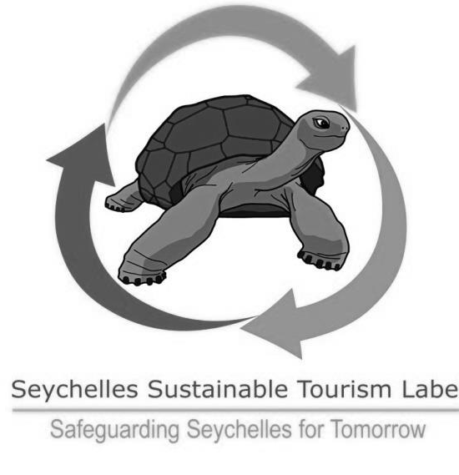
Sustainability Practices

The Department would like to encourage our accommodation sector to incorporate sustainable practices in their business operations and as such a sustainability component has been included in the classification criteria.

In order to ensure that we capture all information relating to this, we have attached the below form for your actions. Please fill in where practices are being done by the hotel and attach relevant supporting documents where applicable.

Note that establishments which are certified as a Seychelles Sustainable Tourism Label (SSTL) Hotel will qualify for 100% of the Sustainable Practices points and are not required to fill in this section.

Category | Yes/No | Required Supporting Evidence to be attached | Remarks
Management
The hotel has a sustainable tourism policy appropriate to the size of the business, which includes a vision statement, and identifies goals in at least three of the following: waste, water, energy, staff, conservation, community, or guests. |  | Copy of sustainable policy documents
The hotel has a valid certification with any international accreditation body for quality, environmental or hygiene standards (e.g.: ISO, Green Globe, HACCP etc.) |  | Copy of relevant certificate
The hotel has a designated member of staff responsible for overseeing and managing its sustainability practices. |  | Name & designation of person responsible
The hotel has a purchasing policy which favours local suppliers, environmentally friendly products e.g., building materials, capital goods, food, consumables. |  | Copy of Purchasing Policy
The hotel monitors usage of waste, water and energy vis-à-vis occupancy with the aim to reduce consumption over time. |  | Monitoring records for at least the past 6 months
Water Conservation
Regular checks for visible leaks from taps and toilets are done, reported and recorded. |  | Water checks maintenance schedules
Water efficient kitchen/laundry appliances are available. |  | -
Water-saving fittings in place (shower heads and taps which are fitted with aerators or specific water-saving fittings). |  | -
The hotel provides bulk water dispensers in public areas. |  | -
The guest is given an option to decide when s/he wants the towels to be changed. |  | Copy of Notice
The guest is given an option to decide when s/he wants the bed linen to be changed. |  | Copy of Notice
The hotel re-uses its grey water for garden watering. This must be in conformity with relevant agency requirements. |  | Copy of permit for discharge of STP effluent from Ministry of Environment
Garden watering is done either early morning or late afternoon to minimize evaporation. |  | -
Efforts have been taken to reduce water usage in toilets using dual flush, reduced volume cisterns or other effective device. |  | -
The hotel conducts rainwater harvesting. |  | -
Energy Saving
Energy saving light bulbs are used for lighting fixtures. |  | -
Energy-efficient appliances have been installed at the kitchen and laundry. |  | -
Electric equipment is turned off (not on standby) when guest room is not occupied, through use of key card. |  | -
The hotel uses alternative energy supplies (e.g... Solar, PV panels, biogas; hydropower) for the majority of its energy consumption. |  | -
The enterprise uses alternative energy heating systems for hot water. |  | -
Waste Management
The hotel has an established recycling programme. |  | -
Green waste is composted. |  | -
Guest amenities (e.g., soap, shampoo, and lotion) are provided from a bulk dispenser or compostable/recycled bottle or in other sustainable packaging. |  | -
The hotel uses phosphate free laundry and dish washing detergent. |  | -
Community Involvement & Guest Satisfaction
The hotel supports local community initiatives. |  | Copies of related documents such as emails, letters.
The management offers job opportunities/internships for students. |  | -
The hotel has won a national or international award for their facilities or services within the last year. |  | Copies of certificate
The hotel has a programme in place to purchase and contract directly from local suppliers and services e.g.; transportation, fruit, vegetable, fish. |  | -
Conservation
The hotel supports and contributes to biodiversity conservation including natural protected areas and areas of high biodiversity value. |  | -
The hotel maintains a vegetable or fruit garden which supplies produce for guests and/or staff |  | -

