Sustainable Seychelles Recognition and Certification (SS)

Information Sheet

Overview
Sustainable Seychelles Recognition and Certification (SS) is an initiative aimed at promoting and recognizing sustainable practices within the tourism sector. This initiative is applicable to accommodations, restaurants, and tour operators across the Seychelles. The goal of the programme is to foster environmental stewardship, support local communities, and ensure sustainable business practices that contribute positively to the Seychelles' economy and ecosystem.

Recognition Programme
This entry-level recognition serves as a stepping stone for businesses starting their journey towards sustainability. Participants must meet initial sustainable practices, which include basic environmental conservation measures, community involvement, and sustainable management practices. Being recognized provides visibility and promotes the business as environmentally conscious to tourists and industry partners. It also prepares businesses for the more rigorous full certification.

Certification
Sustainable Seychelles Certification is designed for businesses that demonstrate a higher level of commitment and implementation of sustainable practices. It requires a comprehensive adherence to advanced sustainable practices in environmental management, social responsibility, and economic viability. Certified businesses gain a competitive advantage through enhanced marketing opportunities, potential for increased tourism, and alignment with global sustainability standards. Full Certification also signals to customers a serious commitment to protecting the environment and supporting local communities.

Eligibility
All licensed tourism accommodations, restaurants and tour operators can participate in the programme.

Application
Businesses who are interested in certification should submit an application to the Tourism Department.
To be awarded for recognition, The Tourism Department will contact tourism businesses to evaluate their sustainability performance. Businesses who have not been contacted but who are interested in the recognition programme should notify the Tourism Department.
No application fee will be charged for businesses wishing to form part of the recognition programme. A fee is applicable for certification.

Evaluation and Audit
The business' sustainability practices will be assessed based on the SS standards and the scoring system. Upon receipt of notification of interest for SS recognition, the team responsible for SS certification will organize the assessment.

Scoring and Recognition
Points will be awarded based on the assessment of the business's sustainability practices. The total score will determine the recognition level achieved by the business (Level 1, 2, 3) or full certification.

Award Levels
Recognition |  |  | Sustainable Seychelles Certified
Level 1  Blue Recognition | Level 2  Bronze Recognition | Level 3  Silver Recognition
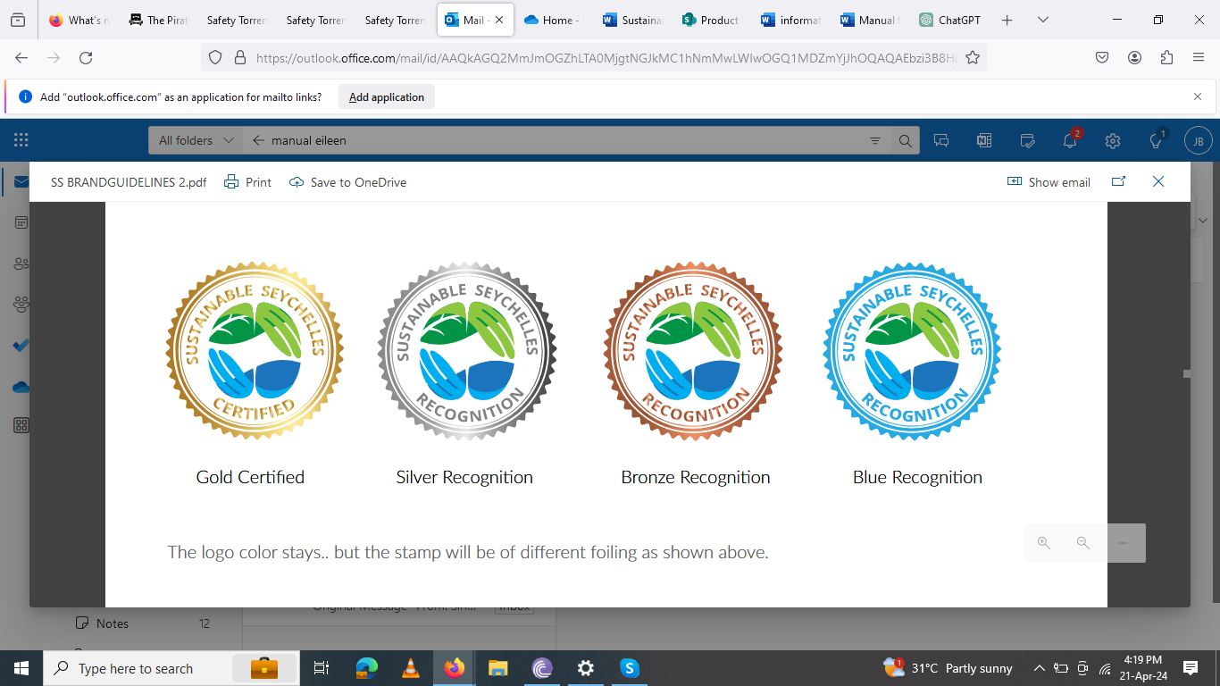
Businesses achieving between 15% to 19% of the total score | Businesses achieving between 20% to 24% of the total score | Businesses achieving between 25% to 29% of the total score  - Businesses achieving a score above 30% of the total scoring but not fulfilling the processes for full certification will be awarded level 3 recognition (Silver Recognition) | - Businesses achieving a minimum score (30%) or above of the total scoring and fulfilling the processes for full certification i.e  - Fulfil all the “must” criteria  - Score an additional six points in any area  will be eligible for Sustainable Seychelles certification.
recognition signifying thatt a business has demonstrated a basic commitment to sustainability practices. | - Level 2 recognition represents a moderate level of commitment with some attempt at incorporating sustainability practices within the businesses’ operations. | - Level 3 recognition indicates that a business has implemented a significant number of sustainability practices. | - Full certification represents a high level of commitment and implementation of sustainability practices.

Recognition
Businesses will be awarded Sustainable Seychelles Recognition at the appropriate level. Businesses that qualify for recognition will be issued a certificate with the level achieved clearly indicated.

Validity of award
The recognition award is valid for 2 years from the date of issue. Businesses will be subject to reassessment to ensure ongoing compliance with the sustainability standards.

Continuous Improvement:
The Program will actively promote continuous improvement among businesses who have achieved recognition by encouraging them to strive for higher recognition levels. The business may request an upgrade to their achieved level by putting in a formal request by letter or email to the Tourism Department.

Support and Resources
Tourism Department offers support and resources to all participants, including guidelines and assistance in implementing sustainable practices. This support is designed to help businesses at every step of their sustainability journey, from initial assessment. For more information, please contact sstlgroup@seychelles.com

