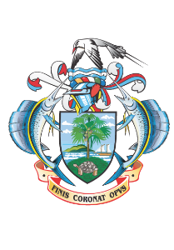

**TOURISM DEPARTMENT**

**PRESS NOTICE**

**PRINTING OF PROMOTIONAL MATERIALS**

The Tourism Department wishes to inform interested parties that it will be undertaking the **Printing of Promotional Materials** through Limited Bidding Method in line with Section 61 2 (a) of the Public Procurement Act 2008.

The proposed shortlisted bidders are as follows:

* Precigraph Limited (Mauritius)
* Emirates Printing Press LLC (Dubai)
* Caractere Ltee (Mauritius)
* United Printing & Publishing (Abu Dhabi)

All potential participants must submit the following mandatory documents along with their interests:

1. Copy of Business Registration Certificate/Certificate of Incorporation.
2. Company profile showing years of experience and examples of past projects.
3. Proof of having the machinery and equipment necessary to carry out printing services.
4. Proof of workmanship/workforce to carry out the service.

Any potential bidders requiring any information on this procurement or wishing to participate in the procurement may contact the Tourism Department, Botanical House, Mont Fleuri during working hours on Tel **(+248) 4671300** or by Email:[**michel.agrippine@seychelles.com**](mailto:michel.agrippine@seychelles.com)and [**procurement@seychelles.com**](mailto:procurement@seychelles.com)not later than **Friday 13th June 2025** at **3.00pm.**

**Any interest should be addressed to:**

**Michel Agrippine**

**Manager Creative & Content Management**

**Tourism Department**

**Botanical House, Mont Fleuri**

**P. O Box 1262**

Interested Bidders may view this press notice on [www.tourism.gov.sc](https://www.tourism.gov.sc) [www.ntb.sc](http://www.ntb.sc) and [www.pou.gov.sc](http://www.pou.gov.sc)